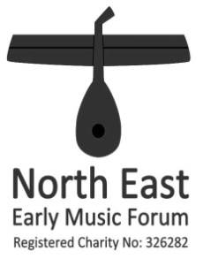
Date
Picture
(optional)
Title of workshop
A workshop for (eg singers / what kind of instruments)
Led by ……………………
(short) Address of venue
Time and Pitch

Blurb about the workshop

Blurb about the conductor

COST £18; concessions £9 (people aged ≤26 or on a very low income e.g. solely dependent on state benefits). STUDENTS FREE.
Refreshments at breaks included. Bring a packed lunch or use local facilities.
Please complete the booking form below and send with a cheque payable to ‘North East Early Music Forum’ to: (name and postal address of organiser) (or book online via workshop diary on our website www.neemf.org.uk). Closing date: (2 weeks before workshop) If you cannot use your booked place, please inform us asap. For more info., please email (organiser’s email address))
✁ - - - - - - - - - - - - - - - - - - - - - - - - - - - - - - - - - - - - - - - - - - - - - - - - - - - - - - - - - - - - - - - - - - -
Title and date Application Form
(Closing date for applications: ………………………)
Completed form and cheque to: (organiser’s name and address)
Name and address (with postcode please)

Postcode
Email _______________________________________________ Tel: ________________________________

I wish to play: ________________________ (indicate instrument(s) approx level (eg starter, pro, student) _________

or I wish to sing: ________________________ (voice) I would be able to sing solo (if required) □
Please also tell us if you have any special requirements (eg large print, transpositions or clefs preferred, etc):
We will email a receipt. If you prefer, we can post an acknowledgement/receipt for which I enclose a stamped SAE □
I enclose a cheque (payable to `North East Early Music Forum’) for £ _______ Do you belong to NEEMF? Yes / No
Is this your first workshop? If so, we will try to arrange a welcomer to meet you. Yes / No
For non-members of NEEMF: May we email you occasionally? Your email address will not be shared with anyone. Yes / No

Signed __________________________________ Date __________________

Directions (to venue, full address inc. postcode)

Venue website: ……………………………………………………………………………………………….

Map here. Not too big so as not to interfere with tear-off overleaf.

Please note: The NEEMF half-price pensioner concession is only for pensioners whose SOLE source of income is the state pension. Pensioners who live on a combination of occupational and state pensions pay the full workshop rate.

